**Derivation of flow graph**

We consider a symmetric two-player three-strategy game defined by the following bi-matrix:



The dynamical graph of this game is given as:

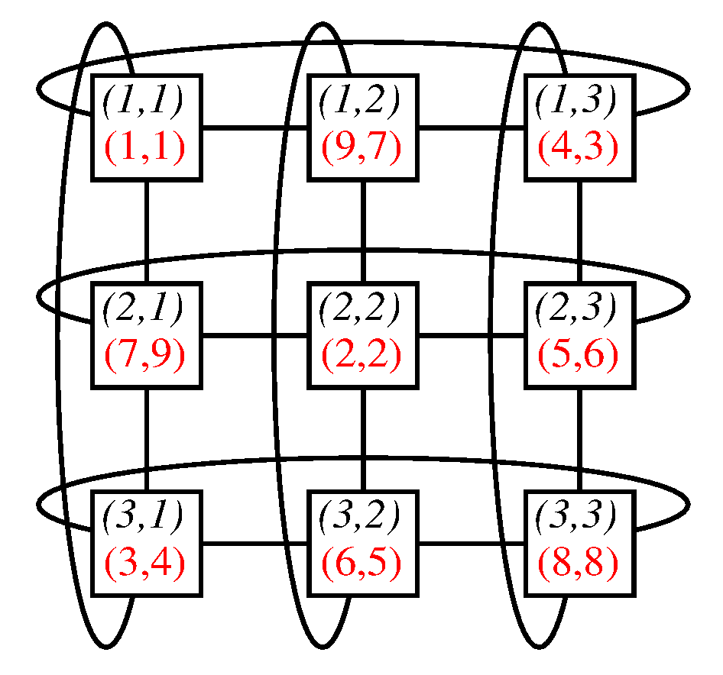

Here the nodes represent strategy pairs (i,j) [i,j=1,2,3] and within the corresponding boxes these strategy profiles are denoted in the upper rows while the resulting payoffs are given in the lower rows. The edges connect those strategy pairs where only one of the players has another strategy. Draw arrows along these edges that indicate the preferred strategy for the active player! After it you can identify the Nash equilibria that are given by those nodes that have no outgoing edges.